目录

1. Transform html to Reactjs 2

1.1 Auto generates 2

1.2 Creating empty components 2

1.3 Define Components 3

1.4 replace index.html 4

1.5 add router 4

1.6 add link 5

2 Test react life cycle 5

3 Add Nodejs login to React 5

3.1 Alter Form 6

3.2 Add events Handler 6

3.3 Add bind 7

3.4 handle form post request 7

# Transform html to Reactjs

npx create-react-app .

## 1.1 Auto generates

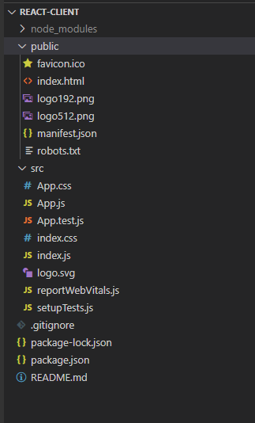

## 1.2 Creating empty components

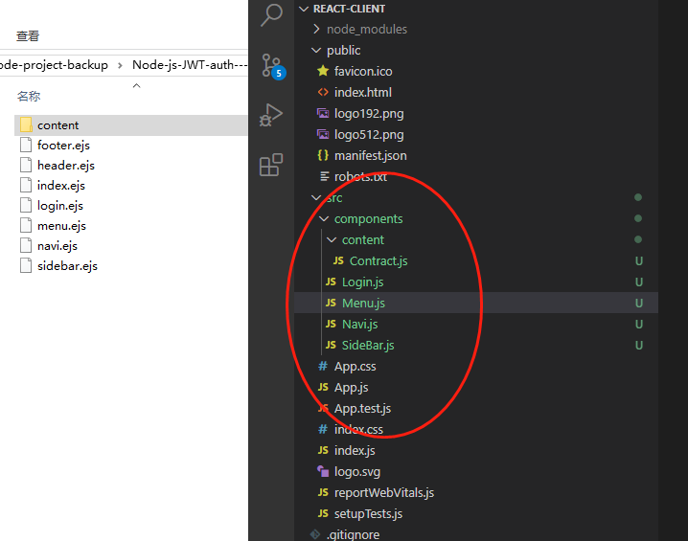

## 1.3 Define Components

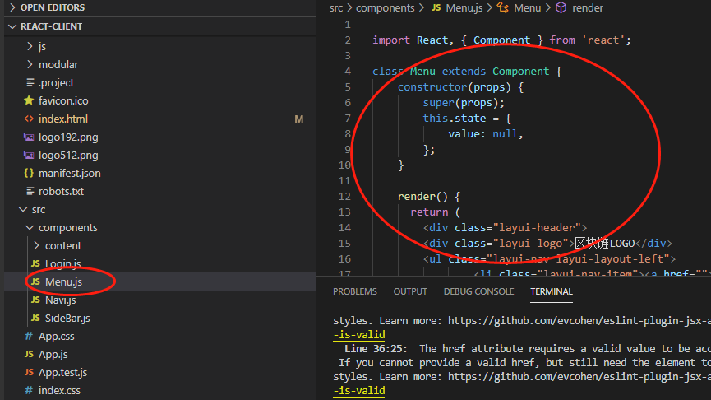

## 1.4 replace index.html

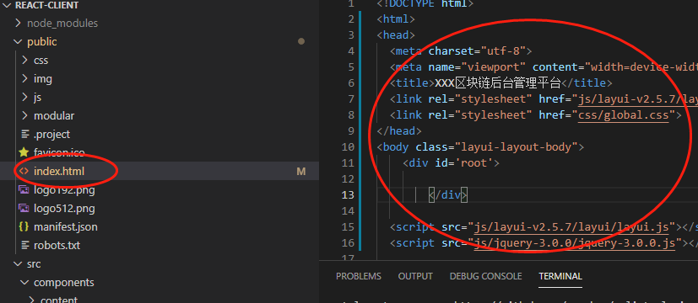

## 1.5 add router

Use exact keyword to do switch

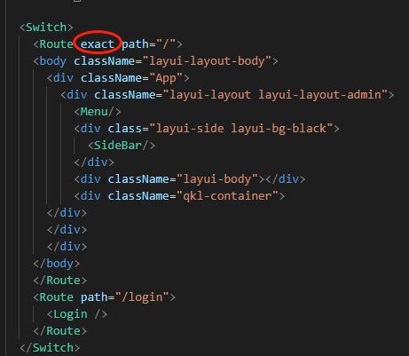

## 1.6 add link

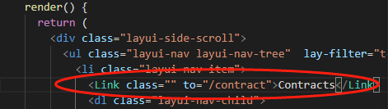

# 2 Test react life cycle

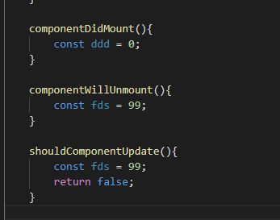

# 3 Add Nodejs login to React

## 3.1 Alter Form

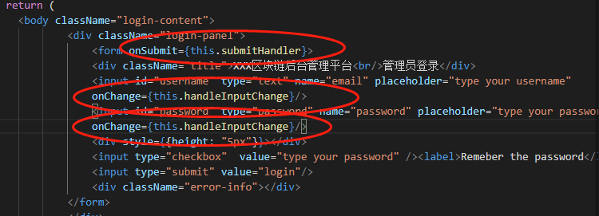

## 3.2 Add events Handler

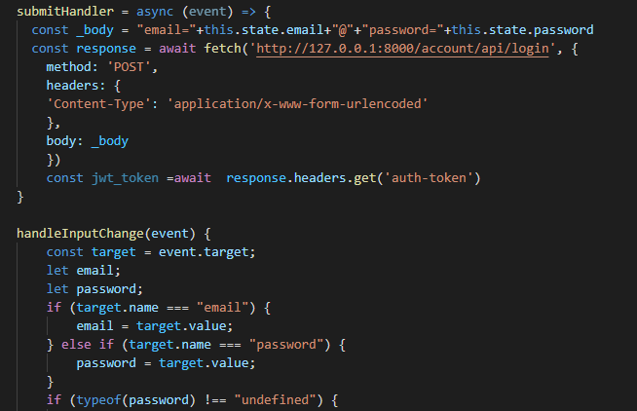

## 3.3 Add bind

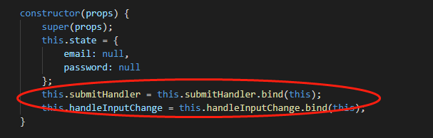

## 3.4 handle form post request

